**Supplementary Material**

**Table S1:** The personality traits characterized by high and low scoring for novelty seeking, harm avoidance and reward dependence dimensions with the corresponding four subscales derived from the Tri-dimensional Personality Questionnaire

|  |  |  |  |
| --- | --- | --- | --- |
| **TPQ dimensions** | **High** | **Low** | **Item (N)** |
| **NS** | **Impulsive & exploratory** | **Reflective & careful** | 33 |
| NS1 | exploratory excitability | stoic rigidity | 9 |
| NS2 | impulsiveness | reflection | 8 |
| NS3 | extravagance | reserve | 7 |
| NS4 | disorderliness | regimentation | 10 |
| **HA** | **Apprehensive & cautious** | **Confident & carefree** | 34 |
| HA1 | anticipatory worry | uninhibited optimism | 10 |
| HA2 | fear of uncertainty | confidence | 7 |
| HA3 | shyness with strangers | gregariousness | 7 |
| HA4 | fatigability and asthenia | vigour | 10 |
| **RD** | **Sentimental & dependent** | **Detached & independent** | 29 |
| RD1 | sentimentality | insensitiveness | 5 |
| RD2 | persistencea | irresoluteness | 9 |
| RD3 | attachment | detachment | 11 |
| RD4 | dependenceb | independence | 5 |

TPQ - Tri-dimensional Personality Questionnaire, NS – novelty seeking, HA – harm avoidance, RD – reward dependence, aOpenness to warm communication/social sensitivity, bOn approval by others, Table adapted from Cloninger et al.45

*00ars, N=16322.9p younger than the all cases group ().een groups ().ell as with the diagnosed onl***Table S2:** The general characteristics for all participants (N=286), junior (N=125) and senior groups (N=161) between the control group (controls), all clinically diagnosed and self-reported concussed cases (all cases) and clinically diagnosed concussed cases only (clinically diagnosed)

|  |  |  |  |  |  |
| --- | --- | --- | --- | --- | --- |
|  | **Controls** | **All cases** | ***P*-value**a | **Clinically diagnosed** | ***P*-value**b |
| *All participants* |  |  |  |  |  |
| **N** | (138) | (163) |  | (140) |  |
| **Age** (yrs.) | 18.9 ± 3.7 (138) | 20.4 ± 4.5 (163) | **0.002** | 20.2 ± 4.2 (140) | **0.005** |
| **Height** (m) | 1.82 ± 0.08 (134) | 1.83 ± 0.08 (161) | 0.207 | 1.84 ± 0.09 (138) | 0.100 |
| **Mass** (kg) | 87.8 ± 16.1 (135) | 91.8 ± 16.8 (158) | **0.041** | 91.8 ± 17.5 (135) | 0.050 |
| **BMI** (kg/m²) | 26.6 ± 3.6 (132) | 27.2 ± 3.7 (155) | 0.150 | 27.3 ± 3.8 (132) | 0.140 |
| **Rugby exposure** (yrs.)c | 10.9 ± 4.1 (138) | 11.1 ± 4.5 (163) | 0.676 | 11.0 ± 4.6 (140) | 0.955 |
| **Non-rugby collision sport exposure** (yrs.)d | 6.0 ± 4.3 (8) | 5.9 ± 3.4 (11) | 0.959 | 5.9 ± 3.9 (8) | 0.952 |
| **Non-rugby contact sport exposure** (yrs.)e | 5.9 ± 4.5 (33) | 7.5 ± 5.8 (49) | 0.193 | 6.9 ± 4.5 (42) | 0.367 |
| **Non-contact sport exposure** (yrs.)f | 14.1 ± 8.2 (99) | 14.6 ± 8.8 (108) | 0.678 | 14.4 ± 9.0 (92) | 0.848 |
| **Total sport exposure** (yrs.)g | 20.5 ± 13.0 (138) | 19.9 ± 13.6 (163) | 0.699 | 22.8 ± 12.6 (140) | 0.982 |
| *Junior* |  |  |  |  |  |
| **N** | (72) | (63) |  | (53) |  |
| **Age** (yrs.) | 16.3 ± 1.3 (72) | 16.4 ± 1.4 (63) | 0.661 | 16.3 ± 1.4 (53) | 0.939 |
| **Height** (m) | 1.80 ± 0.08 (69) | 1.80 ± 0.08 (61) | 0.885 | 1.80 ± 0.08 (41) | 0.979 |
| **Mass** (kg) | 80.0 ± 15.6 (70) | 81.7 ± 16.5 (59) | 0.568 | 80.7 ± 17.3 (49) | 0.825 |
| **BMI** (kg/m²) | 25.0 ± 3.5 (67) | 25.2 ± 4.0 (56) | 0.770 | 25.0 ± 4.2 (46) | 0.915 |
| **Rugby exposure** (yrs.)c | 2.6 ± 1.0 (62) | 2.9 ± 0.8 (46) | 0.116 | 2.9 ± 0.7 (36) | 0.178 |
| **Non-rugby collision sport exposure** (yrs.)d | 5.7 ± 3.5 (3) | 5.6 ± 2.4 (7) | 0.961 | 5.8 ± 2.8 (5) | 0.954 |
| **Non-rugby contact sport exposure** (yrs.)c | 3.8 ± 2.6 (21) | 5.1 ± 3.0 (23) | 0.112 | 4.6 ± 2.9 (19) | 0.346 |
| **Non-contact sport exposure** (yrs.)d | 12.4 ± 7.3 (61) | 13.5 ± 8.0 (56) | 0.447 | 13.2 ± 8.1 (47) | 0.563 |
| **Total sport exposure** (yrs.)e | 17.8 ± 10.9 (72) | 19.4 ± 12.1 (63) | 0.398 | 22.4 ± 10.2 (53) | 0.300 |
| *Senior* |  |  |  |  |  |
| **N** | (66) | (100) |  | (87) |  |
| **Age** (yrs.) | 21.7 ± 3.3 (66) | 22.9 ± 3.9 (100) | **0.038** | 22.6 ± 3.5 (87) | 0.094 |
| **Height** (m) | 1.84 ± 0.08 (65) | 1.85 ± 0.08 (100) | 0.452 | 1.86 ± 0.09 (87) | 0.159 |
| **Mass** (kg) | 96.2 ± 12.0 (65) | 97.8 ± 14.0 (99) | 0.436 | 98.2 ± 14.3 (86) | 0.360 |
| **BMI** (kg/m²) | 28.3 ± 2.9 (65) | 28.4 ± 2.9 (99) | 0.835 | 28.5 ± 3.0 (86) | 0.720 |
| **Rugby exposure** (yrs.)c | 13.3 ± 4.2 (66) | 12.6 ± 4.7 (100) | 0.356 | 12.5 ± 4.7 (87) | 0.286 |
| **Non-rugby collision sport exposure** (yrs.)d | 6.2 ± 5.1 (5) | 6.5 ± 5.1 (4) | 0.932 | 6.0 ± 6.1 (3) | 0.961 |
| **Non-rugby contact sport exposure** (yrs.)e | 9.7 ± (12) | 9.5 ± 6.8 (26) | 0.953 | 8.7 ± 4.8 (23) | 0.587 |
| **Non-contact sport exposure** (yrs.)f | 17.0 ± (38) | 15.9 ± 9.4 (52) | 0.587 | 15.6 ± 9.9 (45) | 0.506 |
| **Total sport exposure** (yrs.)g | 23.5 ± (66) | 20.2 ± 14.5 (100) | 0.154 | 23.1 ± 13.8 (87) | 0.331 |

All values are mean ± standard deviation with the number of participants with non-missing data (N) in parentheses. *P*-values (unadjusted) for the control group compared to **a**all clinically diagnosed and self-reported concussed cases (all cases) and bclinically diagnosed concussed cases only (clinically diagnosed), with significant differences highlighted (*P*<0.05). cSelf-reported number of years playing rugby. dSelf-reported number of years playing other collision sports excluding rugby e.g. combative sports. eSelf-reported number of years playing other contact sports excluding rugby; such as soccer, hockey, water polo/polo, horse-riding, basketball, baseball and motor biking. fSelf-reported number of years playing non-contact sports including swimming, running, golf, cricket, gymnastics, tug-of-war and cycling. gTotal number of years playing all types of sport (contact + non-contact). BMI - body mass index, yrs. – years

Table S3: The general characteristics for all participants (N=286), junior (N=125) and senior groups (N=161) between *DRD2* rs12364283 (G>A), *DRD2* rs1076560 (A>C) and *DRD4* rs1800955 (C>T) variants

|  |  |  |  |
| --- | --- | --- | --- |
|  | ***DRD2* rs12364283** | ***DRD2* rs1076560** | ***DRD4* rs1800955** |
| *All participants* |  |  |  |
| **N** | (283) | (286) | (270) |
| **Age** (yrs.) | 0.655 | 0.510 | 0.710 |
| **Height** (m) | 0.960 | 0.438 | **0.010** |
| **Mass** (kg) | 0.513 | 0.956 | 0.626 |
| **BMI** (kg/m²) | 0.296 | 0.912 | 0.956 |
| **Rugby exposure** (yrs.)a | 0.381 | 0.739 | 0.444 |
| **Non-rugby collision sport exposure** (yrs.)b | **0.013** | 0.296 | 0.656 |
| **Non-rugby contact sport exposure** (yrs.)c | 0.855 | 0.090 | 0.881 |
| **Non-contact sport exposure** (yrs.)d | 0.564 | 0.375 | 0.176 |
| **Total sport exposure** (yrs.)e | 0.569 | 0.276 | 0.339 |
| *Junior* |  |  |  |
| **N** | (118) | (125) | (107) |
| **Age** (yrs.) | 0.056 | 0.744 | 0.269 |
| **Height** (m) | 0.622 | 0.600 | **0.013** |
| **Mass** (kg) | 0.714 | 0.472 | 0.475 |
| **BMI** (kg/m²) | 0.890 | 0.428 | 0.787 |
| **Rugby exposure** (yrs.)a | 0.057 | 0.511 | 0.452 |
| **Non-rugby collision sport exposure** (yrs.)b | 0.876 | 0.522 | 0.952 |
| **Non-rugby contact sport exposure** (yrs.)c | 0.335 | 0.282 | 0.633 |
| **Non-contact sport exposure** (yrs.)d | 0.901 | 0.294 | 0.551 |
| **Total sport exposure** (yrs.)e | 0.506 | 0.266 | 0.074 |
| *Senior* |  |  |  |
| **N** | (165) | (161) | (163) |
| **Age** (yrs.) | 0.396 | 0.865 | 0.405 |
| **Height** (m) | 0.186 | 0.307 | 0.221 |
| **Mass** (kg) | 0.817 | 0.611 | 0.575 |
| **BMI** (kg/m²) | 0.193 | 0.581 | 0.569 |
| **Rugby exposure** (yrs.)a | 0.463 | 0.593 | 0.975 |
| **Non-rugby collision sport exposure** (yrs.)b | **0.013** | 0.101 | 0.715 |
| **Non-rugby contact sport exposure** (yrs.)c | 0.641 | 0.142 | 0.777 |
| **Non-contact sport exposure** (yrs.)d | 0.329 | 0.723 | 0.443 |
| **Total sport exposure** (yrs.)e | 0.434 | 0.505 | 0.467 |

The number of participants with non-missing data (N) is in parentheses. *P*-values for the *DRD2* rs12364283, *DRD2* rs1076560 and *DRD4* rs1800955 genotype effects on different participant characteristics with significant differences (*P*<0.05) highlighted. aSelf-reported number of years playing rugby. bSelf-reported number of years playing other collision sports excluding rugby e.g. combative sports. cSelf-reported number of years playing other contact sports excluding rugby, e.g. soccer, hockey. dSelf-reported number of years playing non-contact sports, e.g. cricket, golf. eTotal number of years playing all types of sport (collision + contact + non-contact). BMI – body mass index, yrs. – years.

**Table S4:** The minor allele frequencies (%) and Hardy-Weinberg Equilibrium (HWE) test for the *DRD2* rs12364283 (A>G), *DRD2* rs1076560 (C>A) and *DRD4* rs1800955 (T>C) variants between the control group (controls), all clinically diagnosed and self-reported concussed cases (all cases) and clinically diagnosed concussed cases only (clinically diagnosed)

|  |  |  |  |  |  |  |  |
| --- | --- | --- | --- | --- | --- | --- | --- |
|  |  | | **Controls** | **All cases** | ***P*-valuea** | **Clinically diagnosed** | ***P*-valueb** |
| *All participants* | N | | (130) | (153) |  | (130) |  |
| ***DRD2* rs12364283** | G allele | | 10.4 (27) | 7.5 (23) | 0.238 | 7.3 (19) | 0.280 |
| HWE | | 0.626 | 0.591 |  | 0.508 |  |
|  | N | | (135) | (151) |  | (128) |  |
| ***DRD2* rs1076560** | A allele | | 15.6 (42) | 16.9 (51) | 0.734 | 16.8 (43) | 0.723 |
|  | HWE | | 1.000 | 0.141 |  | 0.050 |  |
|  | N | | (123) | (147) |  | (124) |  |
| ***DRD4* rs1800955** | C allele | | 43.5 (107) | 41.5 (122) | 0.663 | 41.5 (103) | 0.716 |
|  | HWE | | 1.000 | 0.499 |  | 0.268 |  |
| *Junior* | | N | (64) | (54) |  | (44) |  |
| ***DRD2* rs12364283** | | G allele | 11.7 (15) | 4.6 (5) | 0.062 | 4.5 (4) | 0.087 |
| HWE | 0.189 | 0.092 |  | 0.069 |  |
|  | | N | (70) | (55) |  | (45) |  |
| ***DRD2* rs1076560** | | A allele | 17.1 (24) | 21.8 (24) | 0.419 | 20.0 (18) | 0.603 |
| HWE | 1.000 | 0.702 |  | 0.340 |  |
|  | | N | (58) | (49) |  | (39) |  |
| ***DRD4* rs1800955** | | C allele | 44.0 (51) | 30.6 (30) | 0.049c | 29.5 (23) | 0.050 |
| HWE | 1.000 | 0.173 |  | **0.016** |  |
| *Senior* | N | | (66) | (99) |  | (86) |  |
| ***DRD2* rs12364283d** | G allele | | 9.1 (12) | 9.1 (18) | 1.000 | 12.9 (15) | 1.000 |
|  | HWE | | **-** | - |  | - |  |
|  | N | | (65) | (96) |  | (83) |  |
| ***DRD2* rs1076560** | A allele | | 13.8 (18) | 14.1 (27) | 1.000 | 15.1 (25) | 0.868 |
|  | HWE | | 1.000 | 0.084 |  | 0.079 |  |
|  | N | | (65) | (98) |  | (85) |  |
| ***DRD4* rs1800955** | C allele | | 43.1 (56) | 46.9 (92) | 0.498 | 47.1 (80) | 0.559 |
|  | HWE | | 1.000 | 1.000 |  | 0.829 |  |

The number of junior and senior participants with non-missing data (N) is shown. Allele frequencies are represented as percentages with the equivalent allelic number in parentheses. *P*-values (Fisher’s exact test) comparing allelic (minor vs. major) frequencies between the controls and aall cases group and bclinically diagnosed subgroup. Statistical significance was set at *P*<0.05. HWE are *P*-values from exact tests performed for the *DRD2* and *DRD4* variants. cThe C allele is not significantly different between groups because the upper limit of the confidence interval was too high for an effect size below one (odds ratio 0.37, 95% confidence interval 0.10 – 1.11). dHWE could not be calculated for *DRD2* rs12364283 variant because the GG genotype was absent in seniors. HWE – Hardy-Weinberg Equilibrium

**Table S5:** The mean scores for the Tri-dimensional Personality Questionnaire dimensions; novelty seeking, harm avoidance and reward dependence, between the *DRD2* rs12364283 (A>G), *DRD2* rs1076560 (C>A) and *DRD4* rs1800955 (T>C) genotypes.

|  |  |  |  |  |  |  |  |  |  |  |  |  |
| --- | --- | --- | --- | --- | --- | --- | --- | --- | --- | --- | --- | --- |
| **TPQ dimensions** | ***DRD2* rs12364283** | | | ***P*-value** | ***DRD2* rs1076560** | | | ***P*-value** | ***DRD4* rs1800955** | | | ***P*-value** |
| **AA** | **AG** | **GG** |  | **CC** | **CA** | **AA** |  | **TT** | **CT** | **CC** |  |
| *All participants* |  |  |  |  |  |  |  |  |  |  |  |  |
| **N** | (182) | (34) | (2) |  | (157) | (54) | (8) |  | (65) | (101) | (37) |  |
| **NS** | 16.2 ± 5.2 (179) | 14.3 ± 3.9 (34) | 13.5 ± 6.4 (2) | 0.104 | 15.6 ± 4.7 (154) | 16.4 ± 5.9 (51) | 17.3 ± 7.2 (7) | 0.469 | 16.2 ± 4.4 (65) | 16.0 ± 5.3 (98) | 16.3 ± 5.2 (37) | 0.990 |
| **HA** | 10.5 ± 6.0 (182) | 10.1 ± 5.0 (33) | 11.5 ± 5.0 (2) | 0.915 | 10.9 ± 5.9 (153) | 9.7 ± 5.5 (54) | 10.9 ± 6.4 (8) | 0.329 | 9.5 ± 5.5 (65) | 10.4 ± 6.3 (101) | 11.1 ± 4.6 (37) | 0.326 |
| **RD** | 18.7 ± 4.3 (182) | 19.2 ± 4.4 (33) | 22.5 ± 2.1 (2) | 0.389 | 18.6 ± 4.3 (157) | 19.2 ± 4.5 (50) | 20.5 ± 3.1 (8) | 0.306 | 18.3 ± 4.7 (64) | 19.0 ± 3.9 (101) | 20.1 ± 3.9 (37) | 0.136 |

The means ± standard deviations are presented with total number (N) of participants given in parentheses. Significance set at *P*<0.05 (age-adjusted). HA – harm avoidance, NS – novelty seeking, RD – reward dependence, TPQ - Tri-dimensional Personality Questionnaire.

**Table S6:** The mean scores of the Tri-dimensional Personality Questionnaire dimensions; novelty seeking, harm avoidance and reward dependence, between the control group (controls) and all clinically diagnosed and self-reported concussed cases (all cases) and clinically diagnosed concussed cases only (clinically diagnosed)

|  |  |  |  |  |  |
| --- | --- | --- | --- | --- | --- |
| **TPQ dimensions** | **Controls** | **All cases** | ***P*-value**a | **Clinically diagnosed** | ***P*-value**b |
| *All participants* |  |  |  |  |  |
| **N** | (100) | (127) |  | (109) |  |
| **NS** | 16.0 ± 5.2 (98) | 15.6 ± 4.9 (122) | 0.616 | 15.8 ± 4.9 (103) | 0.781 |
| **HA** | 10.2 ± 5.8 (100) | 10.7 ± 5.8 (125) | 0.309 | 10.6 ± 5.7 (105) | 0.433 |
| **RD** | 18.7 ± 4.1 (98) | 18.8 ± 4.4 (127) | 0.985 | 19.2 ± 4.2 (109) | 0.512 |

The means ± standard deviations are presented with total number (N) of participants given in parentheses. *P*-values for the controls compared to aall cases group and bclinically diagnosed subgroup, with significance set at *P*<0.05 (age-adjusted). TPQ - Tri-dimensional Personality Questionnaire, NS – novelty seeking, HA – harm avoidance, RD – reward dependence.

Table S7: The model of the collective of concussion susceptibility, Tri-dimensional Personality Questionnaire dimensions; novelty seeking, harm avoidance and reward dependence, and the *DRD2* rs12364283 (A>G), *DRD2* rs1076560 (C>A) and *DRD4* rs1800955 (T>C)genotypes

|  |  |  |  |  |  |  |  |  |  |
| --- | --- | --- | --- | --- | --- | --- | --- | --- | --- |
|  |  | **Controls vs. All cases**a | | | | **Controls vs. Clinically diagnosed**b | | | |
|  |  | Coefficient | SE | 95% CI | *P*-value | Coefficient | SE | 95% CI | *P*-value |
| *All participants* |  |  |  |  |  |  |  |  |  |
| **NS** |  |  |  |  |  |  |  |  |  |
| ***DRD2* rs12364283** | A/G | -1.88 | 0.99 | -3.83 ˗ 0.07 | 0.059 | -1.85 | 1.04 | -3.89 ˗ 0.19 | 0.075 |
|  | G/G | -2.85 | 3.53 | -9.77˗ 4.07 | 0.419 | -3.02 | 3.52 | -9.92 ˗ 3.88 | 0.391 |
| ***DRD2* rs1076560** | A/C | 0.53 | 0.82 | -1.07 ˗ 2.14 | 0.514 | 0.68 | 0.87 | -1.03 ˗ 2.38 | 0.436 |
|  | A/A | 3.02 | 2.25 | -1.39 ˗ 7.44 | 0.180 | 2.87 | 2.25 | -1.54 ˗ 7.28 | 0.202 |
| ***DRD4* rs1800955** | C/T | -0.21 | 0.81 | -1.79 ˗ 1.38 | 0.798 | -0.15 | 0.85 | -1.81 ˗ 1.51 | 0.862 |
|  | C/C | 0.23 | 1.04 | -1.80 ˗ 2.27 | 0.822 | 0.34 | 1.11 | -1.84 ˗ 2.51 | 0.762 |
| **HA** |  |  |  |  |  |  |  |  |  |
| ***DRD2* rs12364283** | A/G | -0.42 | 1.14 | -2.65 ˗ 1.81 | 0.711 | -0.38 | 1.18 | -2.69 ˗ 1.94 | 0.751 |
|  | G/G | 0.26 | 4.06 | -7.71 ˗ 8.22 | 0.950 | 0.35 | 4.02 | -7.52 ˗ 8.23 | 0.930 |
| ***DRD2* rs1076560** | A/C | -1.17 | 0.92 | -2.97 ˗ 0.64 | 0.205 | -1.20 | 0.98 | -3.11 ˗ 0.72 | 0.221 |
|  | A/A | -2.86 | 2.37 | -7.51 ˗ 1.79 | 0.229 | -2.76 | 2.35 | -7.36 ˗ 1.85 | 0.241 |
| ***DRD4* rs1800955** | C/T | 0.53 | 0.92 | -1.28 ˗ 2.34 | 0.569 | 0.56 | 0.96 | -1.33 ˗ 2.45 | 0.560 |
|  | C/C | 1.37 | 1.19 | -0.96 ˗ 3.71 | 0.248 | 1.39 | 1.26 | -1.08 ˗ 3.87 | 0.270 |
| **RD** |  |  |  |  |  |  |  |  |  |
| ***DRD2* rs12364283** | A/G | 0.54 | 0.85 | -1.12 ˗ 2.20 | 0.525 | 0.70 | 0.86 | -0.98 ˗ 2.39 | 0.413 |
|  | G/G | 3.40 | 2.97 | -2.41 ˗ 9.21 | 0.252 | 3.45 | 2.87 | -2.18 ˗ 9.08 | 0.229 |
| ***DRD2* rs1076560** | A/C | 0.61 | 0.69 | -0.74 ˗ 1.96 | 0.373 | 1.11 | 0.71 | -0.28 ˗ 2.51 | 0.118 |
|  | A/A | 2.51 | 1.73 | -0.88 ˗ 5.90 | 0.147 | 2.38 | 1.68 | -0.91 ˗ 5.67 | 0.157 |
| ***DRD4* rs1800955** | C/T | 0.65 | 0.68 | -0.68 ˗ 1.97 | 0.339 | 0.25 | 0.69 | -1.10 ˗ 1.59 | 0.719 |
|  | C/C | 1.56 | 0.87 | -0.15 ˗ 3.28 | 0.074 | 0.99 | 0.91 | -0.78 ˗ 2.77 | 0.272 |
| **Concussion history** |  |  |  |  |  |  |  |  |  |
| **NS** |  | -0.04 | 0.03 | -0.10 ˗ 0.02 | 0.217 | -0.03 | 0.03 | -0.10 ˗ 0.03 | 0.346 |
| **HA** |  | 0.04 | 0.03 | -0.01 ˗ 0.10 | 0.117 | 0.04 | 0.03 | -0.02 ˗ 0.10 | 0.155 |
| **RD** |  | 0.01 | 0.04 | -0.06 ˗ 0.08 | 0.789 | 0.04 | 0.04 | -0.04 ˗ 0.12 | 0.346 |
| ***DRD2* rs12364283** | A/G | -0.35 | 0.43 | -1.19 ˗ 0.49 | 0.410 | -0.41 | 0.45 | -1.30 ˗ 0.48 | 0.368 |
|  | G/G | -14.44 | 756.11 | -1596.39 ˗ 1467.50 | 0.985 | -14.33 | 760.36 | -1504.62 ˗ 1475.95 | 0.985 |
| ***DRD2* rs1076560** | A/C | 0.02 | 0.36 | -0.68 ˗ 0.72 | 0.954 | -0.15 | 0.38 | -0.90 ˗ 0.59 | 0.688 |
|  | A/A | 0.41 | 0.96 | -1.47 ˗ 2.30 | 0.669 | 0.50 | 0.97 | -1.39 ˗ 2.40 | 0.603 |
| ***DRD4* rs1800955** | C/T | 0.18 | 0.35 | -0.51 ˗ 0.87 | 0.613 | 0.34 | 0.37 | -0.39 ˗ 1.06 | 0.360 |
|  | C/C | -0.10 | 0.45 | -0.98 ˗ 0.79 | 0.832 | -0.21 | 0.49 | -1.17 ˗ 0.74 | 0.659 |
| *Junior* |  |  |  |  |  |  |  |  |  |
| **NS** |  |  |  |  |  |  |  |  |  |
| ***DRD2* rs12364283** | A/G | -3.12 | 1.90 | -6.85 ˗ 0.61 | 0.101 | -2.71 | 2.17 | -6.97 ˗ 1.55 | 0.212 |
|  | G/G | -1.85 | 2.89 | -7.52 ˗ 3.82 | 0.523 | -2.05 | 2.99 | -7.91 ˗ 3.81 | 0.492 |
| ***DRD2* rs1076560** | A/C | 0.31 | 1.10 | -1.85 ˗ 2.46 | 0.781 | 0.96 | 1.27 | -1.53 ˗ 3.46 | 0.449 |
|  | A/A | 6.70 | 4.40 | -1.91 ˗ 15.32 | 0.127 | 5.74 | 4.69 | -3.45 ˗ 14.92 | 0.221 |
| ***DRD4* rs1800955** | C/T | -0.77 | 1.13 | -2.99 ˗ 1.45 | 0.496 | -0.51 | 1.24 | -2.94 ˗ 1.93 | 0.683 |
|  | C/C | -2.63 | 1.50 | -5.56 ˗ 0.30 | 0.078 | -1.66 | 1.73 | -5.06 ˗ 1.73 | 0.337 |
| **HA** |  |  |  |  |  |  |  |  |  |
| ***DRD2* rs12364283** | A/G | -1.78 | 2.38 | -6.45 ˗ 2.89 | 0.455 | -1.95 | 2.53 | -6.92 ˗ 3.02 | 0.441 |
|  | G/G | -0.34 | 3.99 | -8.16 ˗ 7.48 | 0.932 | -0.74 | 3.92 | -8.44 ˗ 6.95 | 0.850 |
| ***DRD2* rs1076560** | A/C | -0.10 | 1.45 | -2.95 ˗ 2.75 | 0.945 | -0.38 | 1.61 | -3.53 ˗ 2.77 | 0.814 |
|  | A/A | -3.64 | 6.01 | -15.41 ˗ 8.14 | 0.545 | -4.43 | 6.05 | -16.29 ˗ 7.43 | 0.464 |
| ***DRD4* rs1800955** | C/T | -1.03 | 1.52 | -4.01 ˗ 1.94 | 0.496 | -1.57 | 1.60 | -4.71 ˗ 1.57 | 0.327 |
|  | C/C | 2.13 | 2.07 | -1.93 ˗ 6.19 | 0.305 | 2.71 | 2.29 | -1.77 ˗ 7.19 | 0.236 |
| **RD** |  |  |  |  |  |  |  |  |  |
| ***DRD2* rs12364283** | A/G | -1.36 | 1.76 | -4.82 ˗ 2.10 | 0.440 | 0.17 | 1.83 | -3.42 ˗ 3.76 | 0.927 |
|  | G/G | 3.18 | 2.67 | -2.06 ˗ 8.42 | 0.234 | 3.08 | 2.51 | -1.84 ˗ 8.01 | 0.220 |
| ***DRD2* rs1076560** | A/C | 0.43 | 1.01 | -1.55 ˗ 2.41 | 0.669 | 1.62 | 1.07 | -0.47 ˗ 3.71 | 0.128 |
|  | A/A | 2.74 | 4.07 | -5.23 ˗ 10.71 | 0.501 | 0.94 | 3.94 | -6.79 ˗ 8.67 | 0.811 |
| ***DRD4* rs1800955** | C/T | 4.45 | 1.04 | 2.41 ˗ 6.49 | **0.000** | 5.01 | 1.05 | 2.95 ˗ 7.06 | **0.000** |
|  | C/C | 3.06 | 1.39 | 0.32 ˗ 5.79 | **0.028** | 3.95 | 1.46 | 1.09 ˗ 6.81 | **0.007** |
| **Concussion history** |  |  |  |  |  |  |  |  |  |
| **NS** |  | -0.13 | 0.08 | -0.29 ˗ 0.03 | 0.120 | -0.10 | 0.09 | -0.27 ˗ 0.08 | 0.272 |
| **HA** |  | -0.09 | 0.06 | -0.20 ˗ 0.03 | 0.129 | -0.08 | 0.06 | -0.20 ˗ 0.04 | 0.188 |
| **RD** |  | 0.01 | 0.08 | -0.15 ˗ 0.17 | 0.906 | 0.06 | 0.10 | -0.13 ˗ 0.25 | 0.536 |
| ***DRD2* rs12364283** | A/G | -0.77 | 1.13 | -2.99 ˗ 1.45 | 0.495 | -1.19 | 1.37 | -3.88 ˗ 1.50 | 0.387 |
|  | G/G | -14.14 | 1080.13 | -2131.16 ˗ 2102.87 | 0.990 | -14.82 | 1446.27 | -2849.46 ˗ 2819.82 | 0.992 |
| ***DRD2* rs1076560** | A/C | 1.21 | 0.70 | -0.16 ˗ 2.58 | 0.082 | 0.51 | 0.82 | -1.09 ˗ 2.12 | 0.531 |
|  | A/A | -12.19 | 1589.62 | -3127.78 ˗ 3103.40 | 0.994 | 0.69 | 2860.23 | -5605.27 ˗ 5606.64 | 1.000 |
| ***DRD4* rs1800955** | C/T | -0.31 | 0.74 | -1.76 ˗ 1.14 | 0.678 | -0.29 | 0.83 | -1.91 ˗ 1.34 | 0.731 |
|  | C/C | -1.95 | 1.07 | -4.04 – 0.14 | 0.068 | -15.63 | 885.37 | -1750.92 ˗ 1719.66 | 0.986 |
| *Senior* |  |  |  |  |  |  |  |  |  |
| **NS** |  |  |  |  |  |  |  |  |  |
| ***DRD2* rs12364283c** | A/G | -1.62 | 1.20 | -3.98 ˗ 0.73 | 0.177 | -1.78 | 1.25 | -4.22 ˗ 0.66 | 0.153 |
| ***DRD2* rs1076560** | A/C | 0.65 | 1.09 | -1.49 ˗ 2.78 | 0.552 | 0.45 | 1.12 | -1.75 ˗ 2.65 | 0.689 |
|  | A/A | 2.91 | 2.70 | -2.37 ˗ 8.19 | 0.280 | 2.64 | 2.68 | -2.61 ˗ 7.89 | 0.325 |
| ***DRD4* rs1800955** | C/T | 0.12 | 1.08 | -2.00 ˗ 2.23 | 0.914 | -0.03 | 1.12 | -2.21 ˗ 2.16 | 0.981 |
|  | C/C | 1.47 | 1.36 | -1.20 ˗ 4.13 | 0.281 | 1.04 | 1.42 | -1.75 ˗ 3.83 | 0.464 |
| **HA** |  |  |  |  |  |  |  |  |  |
| ***DRD2* rs12364283c** | A/G | 0.06 | 1.32 | -2.52 ˗ 2.64 | 0.962 | 0.14 | 1.35 | -2.51 ˗ 2.79 | 0.918 |
| ***DRD2* rs1076560** | A/C | -1.94 | 1.18 | -4.25 ˗ 0.36 | 0.098 | -1.57 | 1.20 | -3.92 ˗ 0.78 | 0.191 |
|  | A/A | -2.43 | 2.63 | -7.58 ˗ 2.72 | 0.355 | -2.18 | 2.59 | -7.26 ˗ 2.91 | 0.402 |
| ***DRD4* rs1800955** | C/T | 1.47 | 1.16 | -0.80 ˗ 3.74 | 0.205 | 1.68 | 1.19 | -0.65 ˗ 4.00 | 0.157 |
|  | C/C | 1.53 | 1.46 | -1.33 ˗ 4.39 | 0.295 | 1.40 | 1.52 | -1.58 ˗ 4.37 | 0.357 |
| **RD** |  |  |  |  |  |  |  |  |  |
| ***DRD2* rs12364283c** | A/G | 1.14 | 0.93 | -0.68 ˗ 2.95 | 0.218 | 1.21 | 0.92 | -0.59 ˗ 3.01 | 0.187 |
| ***DRD2* rs1076560** | A/C | 0.85 | 0.83 | -0.78 ˗ 2.48 | 0.307 | 0.91 | 0.82 | -0.70 ˗ 2.52 | 0.268 |
|  | A/A | 2.55 | 1.84 | -1.05 ˗ 6.16 | 0.165 | 2.26 | 1.75 | -1.17 ˗ 5.69 | 0.197 |
| ***DRD4* rs1800955** | C/T | -1.58 | 0.81 | -3.17 ˗ 0.00 | 0.050 | -2.30 | 0.80 | -3.87 ˗ (-0.74) | **0.004** |
|  | C/C | 0.37 | 1.03 | -1.64 ˗ 2.38 | 0.718 | -0.77 | 1.03 | -2.78 ˗ 1.25 | 0.456 |
| **Concussion history** |  |  |  |  |  |  |  |  |  |
| **NS** |  | -0.03 | 0.04 | -0.10 ˗ 0.05 | 0.504 | -0.02 | 0.04 | -0.09 ˗ 0.06 | 0.662 |
| **HA** |  | 0.10 | 0.04 | 0.03 ˗ 0.18 | **0.007** | 0.11 | 0.04 | 0.03 ˗ 0.19 | **0.008** |
| **RD** |  | 0.01 | 0.05 | -0.09 ˗ 0.11 | 0.860 | 0.04 | 0.06 | -0.07 ˗ 0.15 | 0.450 |
| ***DRD2* rs12364283c** | A/G | -0.36 | 0.51 | -1.35 ˗ 0.63 | 0.478 | -0.41 | 0.53 | -1.45 ˗ 0.64 | 0.446 |
| ***DRD2* rs1076560** | A/C | -0.33 | 0.46 | -1.24 ˗ 0.57 | 0.467 | -0.39 | 0.48 | -1.33 ˗ 0.55 | 0.417 |
|  | A/A | 0.86 | 1.23 | -1.55 ˗ 3.27 | 0.484 | 0.87 | 1.22 | -1.52 ˗ 3.26 | 0.477 |
| ***DRD4* rs1800955** | C/T | 0.25 | 0.46 | -0.66 ˗ 1.15 | 0.594 | 0.40 | 0.49 | -0.56 ˗ 1.36 | 0.415 |
|  | C/C | 0.50 | 0.58 | -0.64 ˗ 1.65 | 0.388 | 0.52 | 0.61 | -0.67 ˗ 1.71 | 0.394 |

For all participants, juniors and seniors, in the three top-most panels the *P-*values compare the TPQ score differences betweenrs12364283 (**A**>G), rs1076560 (**C**>A) and rs1800955 (**T**>C) genotypes (with the major alleles as reference), while the bottom-most panel compared the TPQ score differences between control and case groups (with the control as reference) and the genotype frequency differences between control and case groups. Significant differences are highlighted (*P*<0.05, generalised structural equation modelling). The model included either athe control group (controls) and all clinically diagnosed and self-reported concussed cases (all cases), or bthe controls and clinically diagnosed concussed cases only (clinically diagnosed subgroup). cThe rs12364283 GG genotype is missing in seniors. HA – harm avoidance, NS – novelty seeking, RD – reward dependence, SE – standard error of the regression coefficient, TPQ - Tri-dimensional Personality Questionnaire.

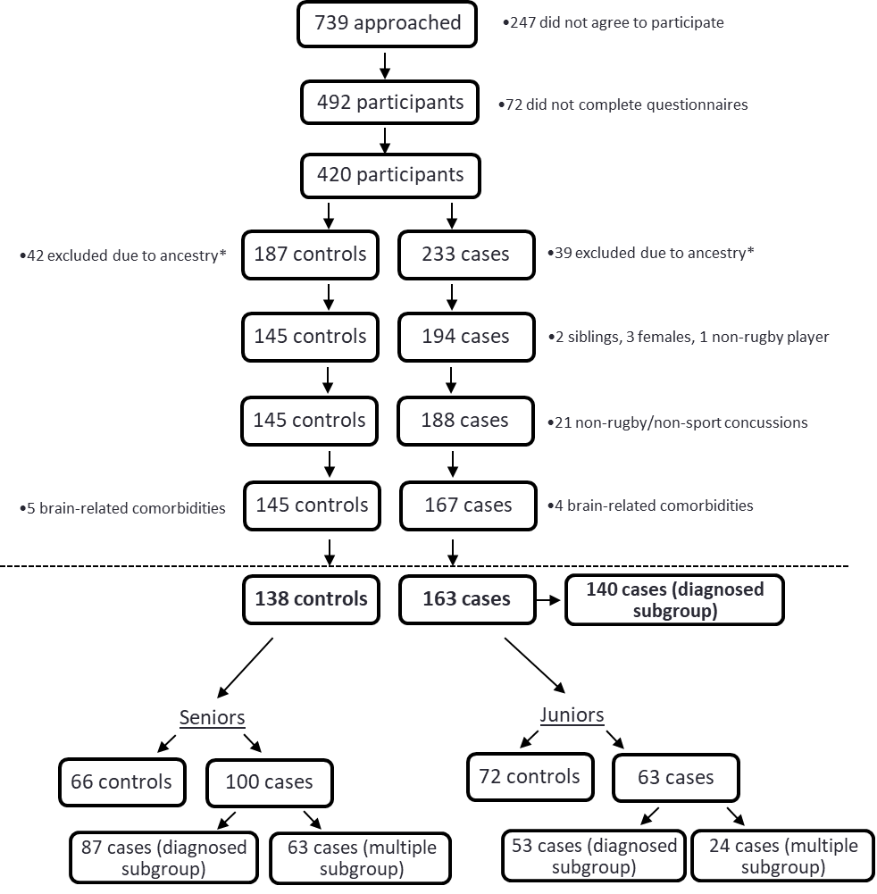

**Figure S1: Participant recruitment and eligibility**

The number of participants recruited in the study (highlighted in boxes), are displayed as control and case groups, with the number (and reason) of excluded participants (not highlighted). The final total participants included and analysed are indicated, with 138 without concussions (control) and 163 with a previous concussion (case), and a subgroup of 140 participants with only clinically diagnosed concussions. *Participants of similar ancestry can only be compared because of population stratification and therefore only participants who had self-reported white ancestry, who presented the majority of the cohort, were analysed in this study. Brain-related comorbidities refer to self-reported meningitis, stroke and seizures.

**Figure S2:** **The *DRD2* and *DRD4* genes**



A) The *DRD2* gene is located on chromosome 11q23, consisting of seven exons (shaded boxes); with the 5’- and 3’-untranslated regions (UTRs; clear boxes) and a one cm scale bar are depicted. The rs12364283 (A>G) and rs1076560 (C>A) variants are indicated on the *DRD2* gene with the single nucleotide change, the NCBI accession number, chromosomal position in parentheses, the distance between variants and between rs12364283 and the promoter region displayed. B) The *DRD4* gene, located at chromosome 11p15.5, consisting of four exons (shaded boxes) with the 5’- and 3’-UTRs (clear boxes) and a one cm scale bar are depicted. The rs1800955 (T>C) variant is indicated on the *DRD4* gene with the single nucleotide change, the NCBI accession number, chromosomal position in parentheses, and the distance between rs1800955 and the promoter region displayed. In both A and B, the start and stop codons are indicated by a closed triangle and circle, respectively. The glycosylation sites are indicated by a blue rectangle and disulphide bonds are indicated by an open triangle. This figure was constructed from information obtained using the database hosted by NCBI (<http://www.ncbi.nlm.nih.gov/>, GRCh38p7 assembly) and the Geneious software version 10.0.9.377 *ANKK1* – ankyrin repeat and kinase domain containing 1 gene, bp - base pairs, Ch. – chromosome, *DEAF1* – DEAF1 transcription factor gene, *DRD2* – dopamine receptor D2 gene, *DRD4* – dopamine receptor D4 gene, kbp - kilobase pairs, *MIR4301* - microRNA 4301, NCBI – National Centre for Biotechnology Information, *SCT* – secretin gene.

**Figure S3:** The genotype frequencies (%) between the control group (controls), all clinically diagnosed and self-reported concussed cases (all cases) and clinically diagnosed concussed cases only (clinically diagnosed); for the **A)** *DRD2* rs12364283 (A>G), *DRD2* rs1076560 (C>A) and *DRD4* rs1800955 (T>C) variants in all participants (N=286). **B)** The inferred *DRD2* rs12364283-rs1076560-*DRD4* rs1800955 allele combination frequencies (%) between groups. Statistical significance was set at *P*<0.05 (age-adjusted). All three variants were in HWE for control and case groups for all participants (*P*>0.05). HWE – Hardy-Weinberg equilibrium



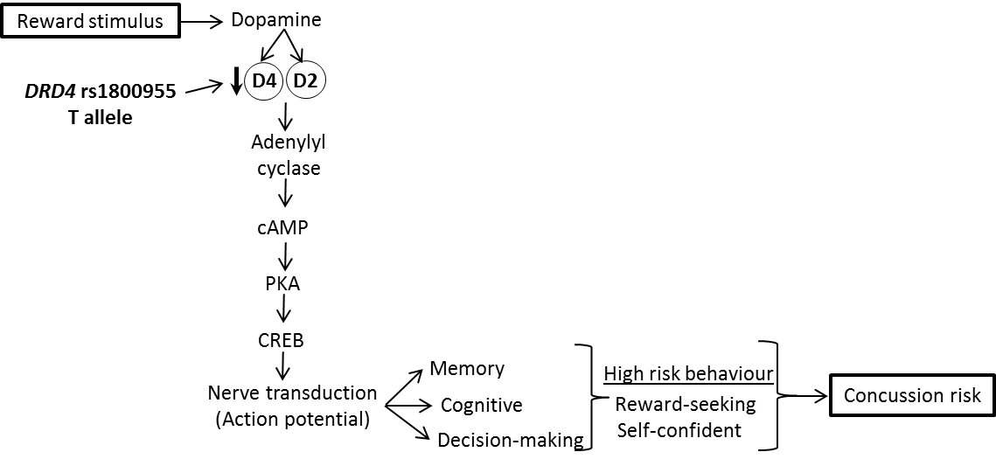**Figure S4: Dopaminergic post-synaptic pathway**

The release of dopamine through novel or reward stimulation can lead to binding to the dopamine D2/D4 receptors, encoded by the *DRD2* and *DRD4* genes, which act on nerve transduction via inhibition of the adenylyl cyclase pathway. Altering nerve transduction results in behaviour modulation, including memory, cognitive and decision-making behaviour, which could play a role in high risk behaviour and concussion susceptibility. D2 – dopamine D2 receptor, D4 – dopamine D4 receptor, cAMP – cyclic adenosine monophosphate, PKA – protein kinase A, CREB – cAMP response element binding protein. This diagram was collated from previous literature Missale et al.50, Beaulieu et al.23 and Löber et al.24.